**BLG368E - Object Oriented Modeling and Design**

**Assignment 2**

Kadir Emre Oto (150140032)

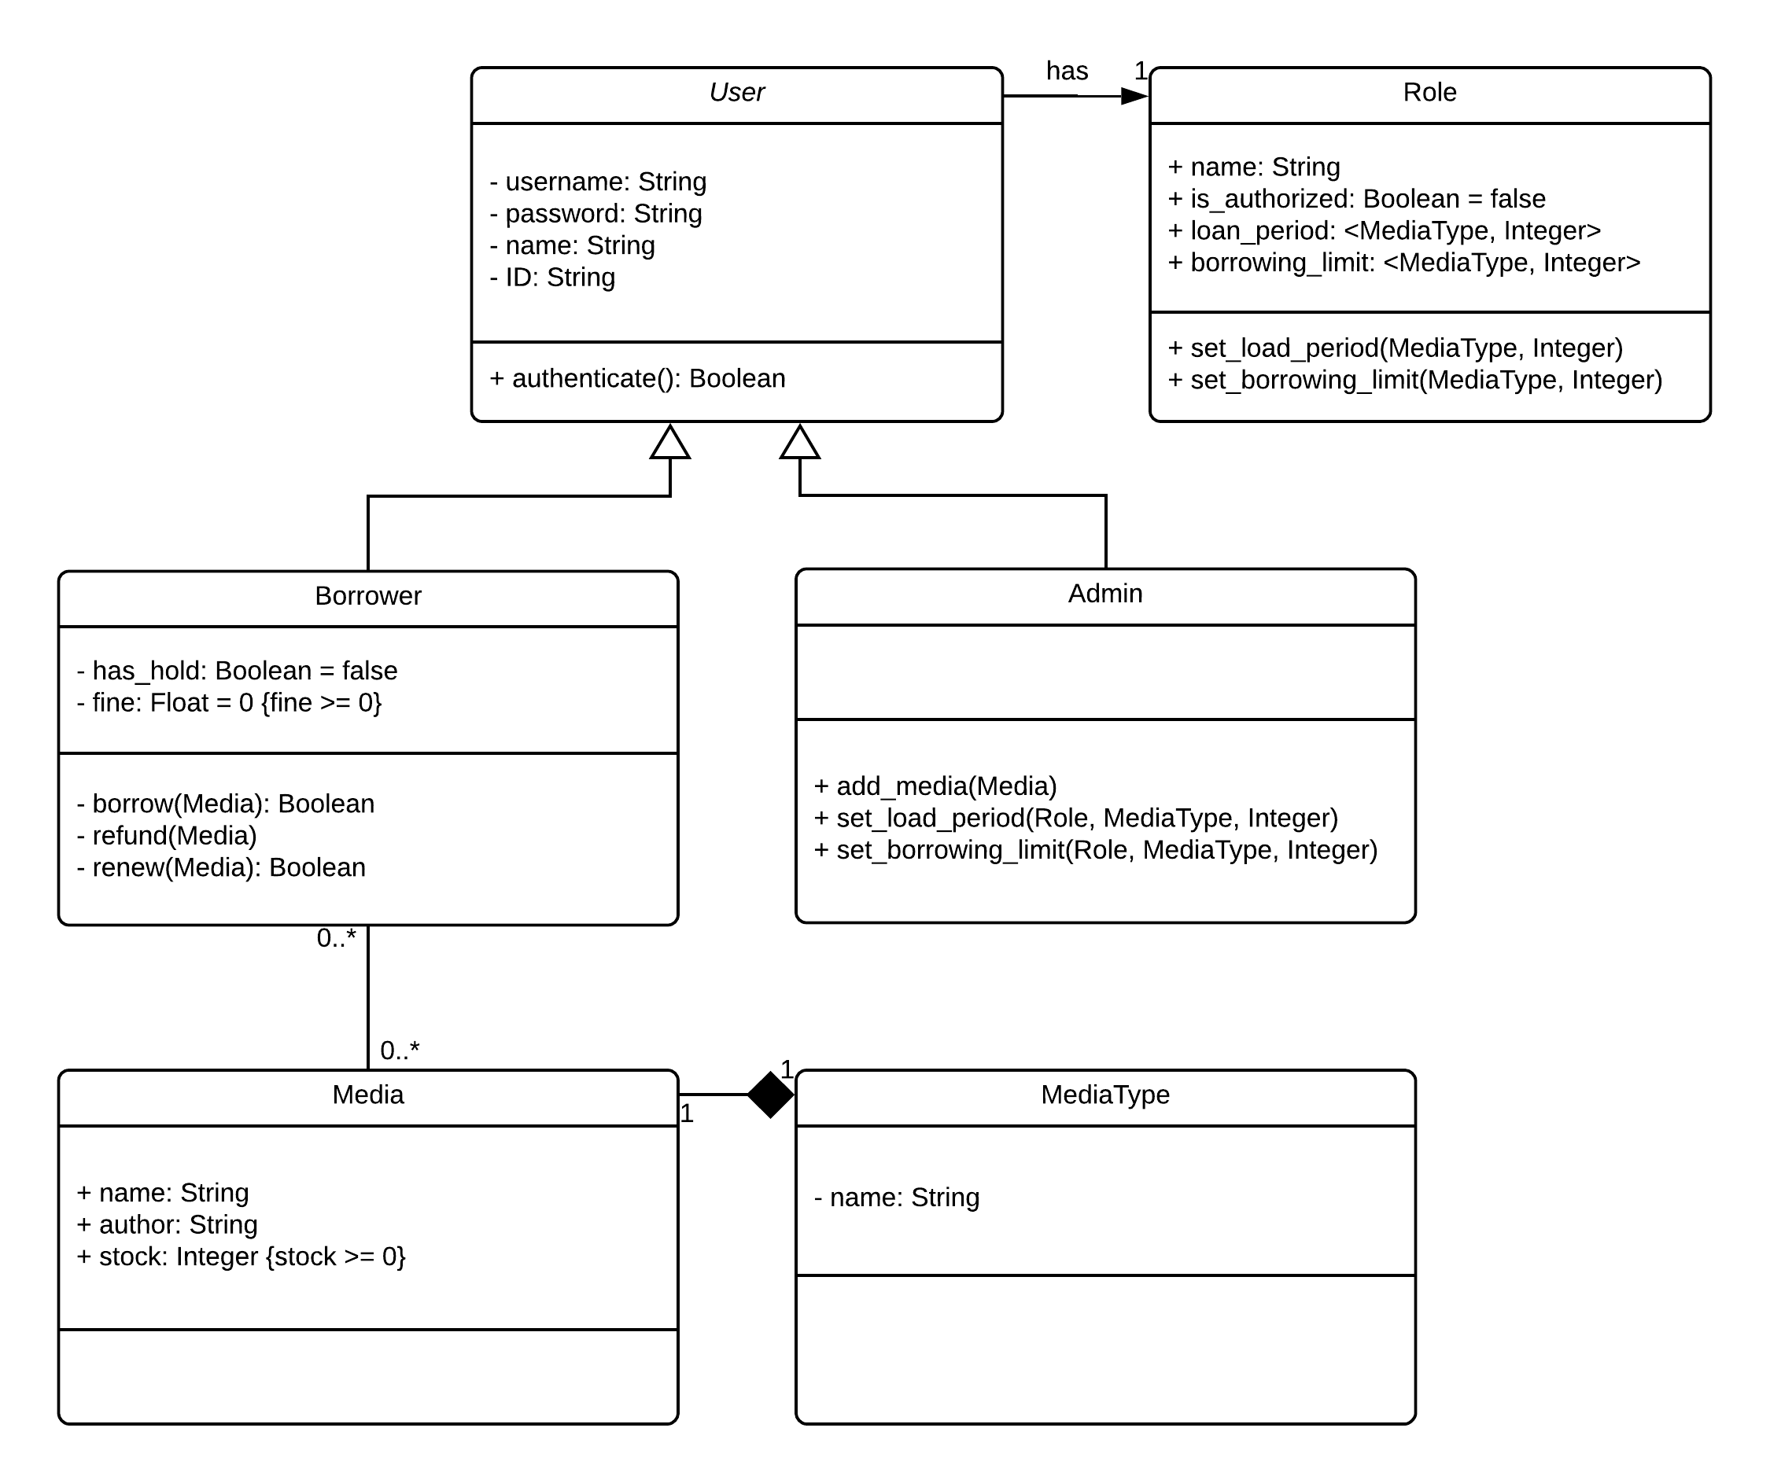

UML Diagram for Library Automation System